Working With Statics

So what does the term *static* mean in Java? It’s used to describe a special type of

field or method that isn’t associated with a particular instance of a class. Instead,

static fields and methods are associated with the class itself, which means that

you don’t have to create an instance of the class to access a static field or methods.

Instead, you access a static field or method by specifying the class name, not a

variable that references an object.

* The value of a static field is the same across all instances

private static int ballCount;

static private int ballCount;

Convention to put visibility keyword first

The best-known static method is main, which is called by the Java runtime to start

an application. The main method must be static — which means that applications

are run in a static context by default.

One of the basic rules of working with static methods is that you can’t access a

nonstatic method or field from a static method, because the static method doesn’t

have an instance of the class to use to reference instance methods or fields.

You *can* access static methods and fields from an instance method

One common use for static variables is to keep track of how many instances of a

class have been created.

Sometimes you want to create a class that can’t be instantiated at all. Such a class

consists entirely of static fields and methods.

All you have to do to prevent a class instance from being created, then, is provide

a single private constructor.

Java provides a feature called a *static initializer* that’s designed specifically to let

you initialize static fields.

If a class has more than one static initializer, the initializers are executed in the

order in which they appear in the program.

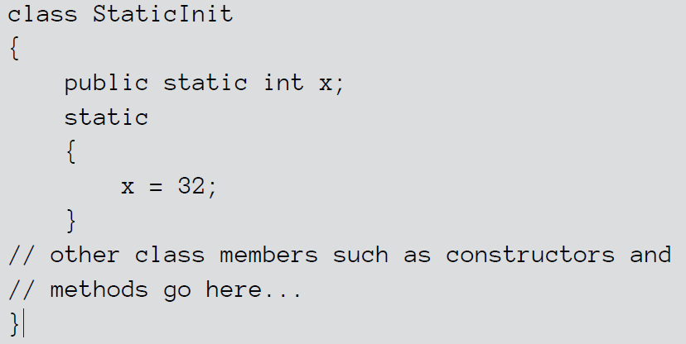

Using the Object and Class Classes

* Every object is a Object
* No extends on a class then that class extends Object
* Object can be a type
* ArrayList constructor accepts Object as a argument
* Primitives aren’t Objects

# Methods

clone: This method is commonly used to make copies of objects, and

overriding it in your own classes is not uncommon. I explain this method in

detail later in this chapter, in the section “The clone Method.”

equals: This method is commonly used to compare objects. Any class that

represents an object that can be compared with another object should

override this method. Turn to the section “The equals Method,” later in this

chapter, for more info.

finalize: This method is called when the garbage collector realizes that an

object is no longer being used and can be discarded. The intent of this

method is to let you create objects that clean up after themselves by closing

open files and performing other cleanup tasks before being discarded. But

because of the way the Java garbage collector works, there’s no guarantee

that the finalize method is ever actually called. As a result, this method isn’t

commonly used.

getClass: This method is sometimes used in conjunction with the Class

class, which I describe later in this chapter, in the section “The Class Class.”

hashCode: Every Java object has a *hash code,* which is an int representation of

the class that’s useful for certain operations. This method isn’t terribly

important until you start to work with hash tables — which is a pretty

advanced technique, best left to people with pocket protectors and tape

holding their glasses together.

toString: This method is one of the most commonly used methods in Java.

I describe it in the section “The toString Method,” later in this chapter.

getName(): Returns a String representing the name of the classgetSuperclass(): Returns another Class object representing this Class object’s superclass

# The Class Class

Every class used by a Java application is represented in memory by an object of

type Class. If your program uses Employee objects, for example, there’s also a

Class object for the Employee class. This Class object has information not about

specific employees but about the Employee class itself.

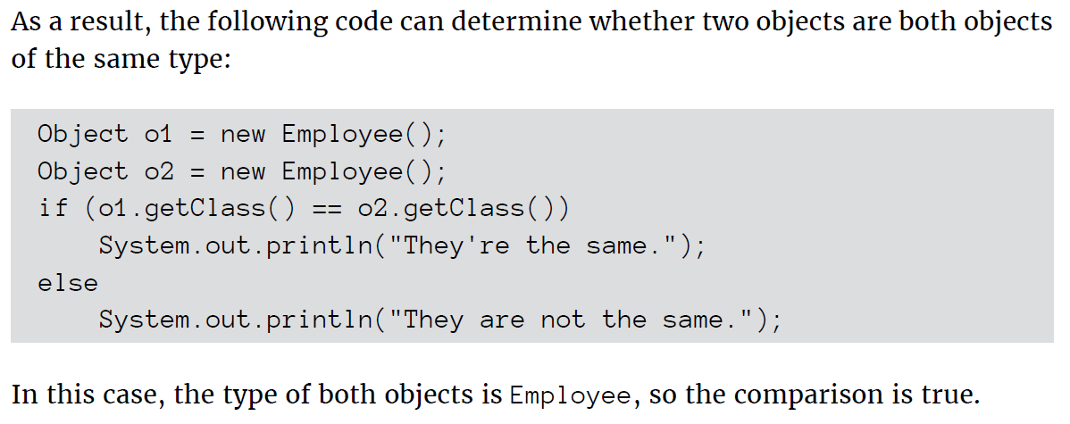

Using the Arraylist Class

# Understanding the Arraylist

* Automatically resizes itself
* Lets you insert elements into the middle of the collection
* Lets you delete items
* Actually uses an array to store data

# Creating Arraylist

* ArrayList signs = new ArrayList();
* ArrayList signs = new ArrayList(100);
* ArrayList<String> signs = new ArrayList<String>();

# Adding Elements

* nums.add("One");
* nums.add(2, "Two and a half");

# Accessing elements

for (int i = 0; i < nums.size(); i++)

System.out.println(nums.get(i));

for (String s : nums)

System.out.println(s);

for (String s : nums)

{

int i = nums.indexOf(s);

System.out.println("Item " + i + ": " + s);

}

# Printing a ArrayList

ArrayList<String> nums = new ArrayList<String>();

nums.add("One");

nums.add("Two");

nums.add("Three");

nums.add("Four");

System.out.println(nums);

[One, Two, Three, Four]

# Using an Iterator

ArrayList<String> nums = new ArrayList<String>();

nums.add("One");

nums.add("Two");

nums.add("Three");  
nums.add("Four");

String s;

Iterator e = nums.iterator();

while (e.hasNext())

{

s = (String)e.next();

System.out.println(s);

}

# Update and Delete

* nums.set(0, "Uno");
* emps.remove(0);
* emps.clear();

Working with Strings

* Strings are reference types, not value types, such as int or boolean. As a result, a string variable holds a reference to an object created from the String class, not the value of the string itself.
* Java lets you assign string literals to string variables
* Strings can include *escape sequences* that consist of a slash followed by another character.
* Strings and characters are different. String literals are marked by quotation marks; character literals are marked by apostrophes. Thus, "a" is a string literal that happens to be one character long. By contrast, 'a' is a character literal.

# Immutable Pattern

* An *immutable object* is an object that, once created, can never be changed.
* Provide one or more constructors that accept parameters to set the initial state of the object.
* Don’t allow any methods to modify any instance variables in the object. Set instance variables with constructors and then leave them alone.
* Any method that modifies the object should do so by creating a new object with the modified values. Then this method returns the new object as its return value.

# Adding to Strings

* You can combine, or *concatenate,* strings by using the + operator
* You can also use the += operator with strings
* When a primitive type is used in a concatenation expression, Java automatically converts the primitive type to a string.
* The various primitive wrapper classes (such as integer and double) have parse methods that can convert string values to numeric types.
* You can’t compare strings by using the equality operator (==). Instead, you should use the equals method.
* The String class also has an equalsIgnoreCase method that compares strings without considering case.

# Different Methods

* S.length()
* String s1 = "Oompa Loompa"; String s2 = s1.toLowerCase();
* String s = " Oompa Loompa "; s = s.trim();

# StringBuilder

* StringBuilder sb = new StringBuilder("Today is the day!");
* Sb.append

Creating Generic Collection Classes

ArrayList<Employee> empList = new ArrayList<Employee>();

In short, if you want to create a method that accepts any type of ArrayList, you

have to code the method like this:

public void addItems(ArrayList<?> list)

In that case, you can add an extends clause to the wildcard, like this:

public void addItems(ArrayList<? extends Employee> list)

Then you can call the addItems method with an ArrayList of type Employee,

HourlyEmployee, or SalariedEmployee.

Now, before you call it a day, take this example one step further: Suppose this

addItems method appears in a generic class that uses a formal type parameter

<E> to specify the type of elements the class accepts, and you want the addItems

method to accept an ArrayList of type E or any of its subclasses. To do that, you’d

declare the addItems method like this:

public void addItems(ArrayList<? extends E> list)

Here the wildcard type parameter <? extends E> simply means that the Array

List can be of type E or any type that extends E.

Java 7 introduced a new feature called the *diamond operator* that lets you skip the

type when you call the constructor, like this:

ArrayList<String> nums = new ArrayList<>();

Here’s another example:

ArrayList<String> nums;

nums = new ArrayList<>();  
The diamond operator simply deduces the correct type based on the variable’s

type.

Anonymous Classes and Lamda Expressions

* Inner Classes
* Static Inner Classes
* Anonymous Classes
* Lamda Expressions

# Inner Class

* Has access to fields and methods of outer class, even private ones
* Carries reference to current instance of outer class unless outer class is static
* Main reason to create inner class, because it is only of interest to outer class
* To reference outer class instance **className.this**

# Static inner Class

* Similar to Inner class but doesn’t need a instance of the outer class
* Can’t access non static fields or methods in outer class

# Using Anonymous Inner Class

* Defined on the spot right at the point where you want to instantiate it
* {}
* Use in a method argument

# Lambda Expressions

* (parameters) -> *expression*
* (parameters) -> { *statement*;...}

Working with packages

1. Pick a name for your package
2. Choose a directory on your hard drive to be the root of your class library
3. Create subdirectories within the root directory for your package name
4. Add the root directory for your package to the classPath environment variable
5. Save the files for any classes you want to be in a particular package in the directory for that package
6. Add a package statement to the beginning of each source file that belongs in the package

# Creating a jar file

1. Open command window
2. Use a cd command to navigate to your package root
3. Use a jar command that specifies the options cf, the name of the jar file, and the path to the class files you want to archive **( jar cf utils.jar com\lowewriter\util\*.class )**
4. To verify that the jar file was created correctly, use the jar command that specifies the options tf and the name of the jar file.
5. Create a manifest file : jar cfm game.jar com\lowewriter\game\game.mf com\lowewriter\game\*.class
6. Run the jar file : java -jar game.jar
7. javadoc com\lowewriter\payroll\*.java

Using Bulk Data Operations With Collections

* one of the most common things to do with a collection is to iterate over it, performing some type of operation on all of its elements.
* Streams rely on the use of lambda expressions to pass the operations that are Performed on stream elements.
* Filter method is most commonly used
* One common use for mapping methods is to convert a stream of complex types to a stream of simple numeric values of type double, int, or long.
* .mapToDouble(s -> s.price)

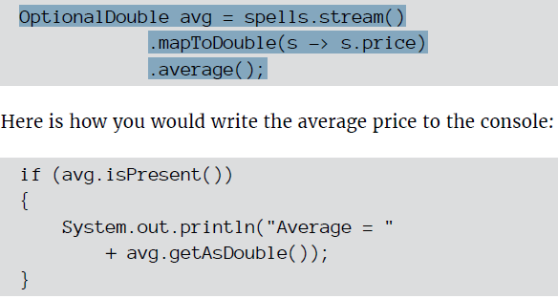

Streams come in two basic flavors: *sequential* and *parallel*. Elements in a sequential

stream are produced by the stream method and create streams that are processed

one element after the next. Parallel streams, in contrast, can take full advantage of

multicore processors by breaking its elements into two or more smaller streams,

performing operations on them, and then recombining the separate streams to

create the final result stream. Each of the intermediate streams can be processed

by a separate thread, which can improve performance for large streams.

By default, streams are sequential. But creating a parallel stream is easy: Just use

the parallelStream method instead of the stream method at the beginning of

the pipeline.

Linked Lists

# Understanding Linked lists

A *linked list* is a collection in which every object in the list maintains with it a

pointer to the following object in the list and another pointer to the preceding

object in the list. No array is involved at all in a linked list. Instead, the list is managed

entirely by these pointers.

## Differences over arraylist

* Linked lists don’t have size issues
* Inserting in the middle of linked list is easy, just change the pointers (Arraylist have to recopy everything)
* Removing from a linked list also just change the pointers
* Well suited for stack and queues
* Linked list uses more memory

# Creating a Linked list

* LinkedList officers = new LinkedList();
* LinkedList<String> officers = new LinkedList<String>(); (This uses the generic way)

# Adding items to a Linked List

* Officers.add(“Blake”)
* Officers.addFirst(“Blake”)
* officers.add(2, "Tuttle");

# Retrieving Items from a Linked List

* getFirst
* element
* peek
* peekFirst
* remove
* removeFirst
* poll
* polFirst
* pop
* getLast
* peekLast
* removeLast
* pollLast

## Updating and Removing LinkedList Items

* officers.set(2, “Murdock”)
* officers.remove(3);
* officers.remove(tuttle);
* officers.clear();

Using Recursion